Press Release

# Fighter for Disability Rights: EvH Bochum bids farewell to Prof Dr. Theresia Degener on her retirement

Bochum, 25 October 2024

She was an activist from the very beginning, a rebel and a pioneer: Prof Dr. Theresia Degener has been campaigning for the rights and equality of disabled people for more than 40 years. A trained lawyer, she played a key role in the drafting of the UN Convention on the Rights of Persons with Disabilities (UN CRPD). She also founded the Bochum Center for Disability Studies (BODYS) which became an important institution for research and teaching in the field of disability rights under her leadership. Prof Degener is now retiring after 26 years at the Protestant University of Applied Sciences Bochum (EvH Bochum).

“Being an outstanding expert in the fields of law and disability studies, Theresia Degener has not only shaped the academic landscape in Germany, but also provided significant impetus at an international level”, said EvH Rector Prof Dr Dr Sigrid Graumann in her speech. “She is an impressive personality who always knew how to combine an academic perspective with her commitment to the disability rights movement. She has given students the opportunity to participate directly in these processes. Everyone has benefited greatly from this.”

Theresia Degener researched international human rights, gender and disability studies as well as anti-discrimination law. In her farewell lecture, she reflected on how disability research has changed in Germany and the obstacles faced by disabled researchers in the academic world. With regard to the EvH Bochum, she said approvingly: “What particularly pleases me is the increasing accessibility. While I still had to organize sign language interpreting for my inaugural lecture myself, the university now pays for it from a fund set up specifically for this purpose. Architectural accessibility has also improved a lot.”

In her last lecture, Degener emphasized the particular importance of the UN CRPD, to which she played a key role – first as a co-author of the background study, then as an independent expert and representative of Germany in the drafting of the international convention. From 2011–2018, she promoted the rights of disabled people as a member and later chair of the United Nations Committee in the Rights of Persons with Disabilities. The UN CRPD provides a legal basis for implementing the rights of people with disabilities in different countries. According to Theresia Degener, one of its fundamental principles is the motto “Nothing about us without us”, both collectively and individually. This also requires a rethink in research, “because human rights-based research calls into question the traditional power relations between researchers and research subjects.”

Juergen Dusel, Federal Government Commissioner for Matters Relating to Persons with Disabilities and board member of BODYS, also picked up on this idea in his festive speech. “Theresia Degener made us realize that implementing the rights of persons with disabilities is not just a nice thing to do, but that it is about asking ourselves in what kind of country we want to live in. Unfortunately, we see that people who have problems with democracy often also have problems with inclusion.”

## Firmly rooted in the disability rights movement

Prof Degener already proved her emancipatory attitude in early publications – for example as co-author of the first book published by disabled women in Germany entitled “Geschlecht behindert, besonderes Merkmal Frau” (sex: disabled, special feature: woman) (1985). Feminist activism remained a matter close to her heart throughout her professional career. “I must emphasize once again how important it is to look at the intersections of gender and disability and to make the specific challenges faced by disabled women visible.”

In addition to research, teaching and networking, the academic Theresia Degener has never forgotten her roots in the disability rights movement, with which she made her first major public appearance in 1981 as a co-prosecutor in the so-called “Krueppeltribunal” (cripples’ tribunal, an infamous adaption of a Russell’s tribunal by the German disability rights movement). Degener invited fellow activists to its anniversary celebrations at the EvH Bochum, so that students repeatedly had the opportunity to meet contemporary witnesses to the history of the disability movement. In 2013, Prof Degener also brought the UN CRPD “home” – to Bochum and the EvH Bochum. Together with Sigrid Graumann, she organized the university’s first accessible, inclusive international conference entitled “Inclusion is Human Right”.

## Career

Prof Dr. Theresia Degener studied law in Frankfurt am Main, Germany, and Berkely, USA. She passed the First State Examination in Law in Frankfurt am Main in 1986 and the Assessor Examination in 1993. In 1992, she completed her doctorate on the subject of “The outpatient care legal relationship as a model of a social law relationship” at the law faculty of the Johann Wolfgang Goethe University in Frankfurt, where she also worked as a post doc researcher (C1) from1995 until 1998. She gained extra-university professional experience as a lawyer with various disability organizations in Germany and abroad (fib e.V. Marburg, DREDF, Berkeley). In 1998, Theresia Degener became Professor of Law, Administration and Organization at the Department of Special Needs Education at the EvH Bochum. In 2010, she transferred to the Department of Social Work, Education and Diaconia as a Professor of Law and Disability Studies.

She has also worked as an expert and consultant for numerous governmental and non-governmental organizations. She has advised the German Bundestag and the German Federal Government, the United Nations, the European Commission and the Organisation for Security and Cooperation in Europe, as well as Disabled People International, the Open Society Foundation and the European Disability Forum. She has taught as a visiting professor at law faculties in the US, South Africa, and the Netherlands.

Theresia Degener is also considered a co-founder of disability studies in German-speaking countries. She has directed the Bochum Center for Disability Studies (BODYS) since 2015.

## Important note on the Bochum Center for Disability Studies (BODYS):

Following the retirement of Prof Dr Theresia Degener, Prof Dr Kathrin Roemisch and Prof Dr Stefan Schache have taken over as interim directors of BODYS. They will be supported by Gudrun Kellermann and Prof Dr Karin Tiesmeyer.

Responsible according to press law: Prof. Dr. Kathrin Römisch

Bochum Center for Disability Studies (BODYS)

EvH Bochum

Immanuel-Kant-Strasse 18-20

D-44803 Bochum/Germany

[bodys@EvH-Bochum.de](mailto:bodys@EvH-Bochum.de)

<https://www.bodys-wissen.de>

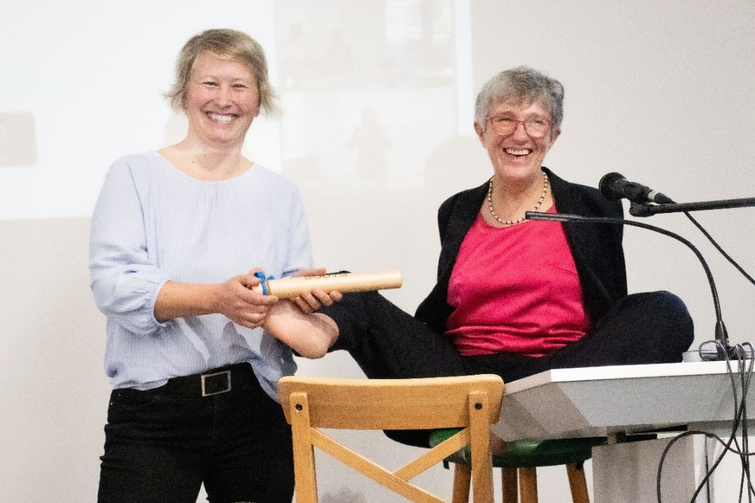

*Prof Dr Kathrin Roemisch (left) takes over the BODYS baton from Prof Dr Theresia Degener (© EvH Bochum)*

Image: Two women in festive dress laugh at the camera and hold a baton together.

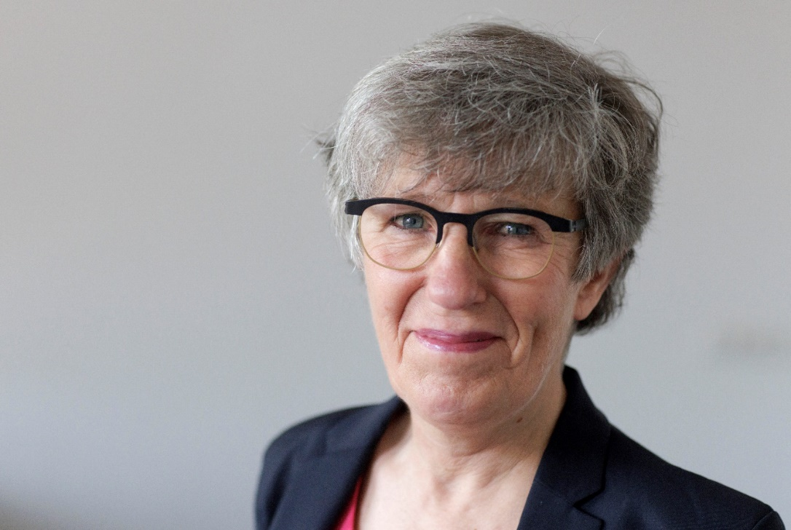

*Prof Dr Theresia Degener has been campaigning for rights and equality of disabled persons for more than 40 years (© Wilfried Gerharz)*

Image: portrait photo of Theresia Degener

**Download**  
[>> Download high resolution images here](https://evh-bochum.canto.de/b/J57UT)